For built in django user creation we can use UserCreationForm from contrib.auth.forms

Django has a built in User model including a username & email, the form will include 2 passwords so that they will not be saved if they don't match



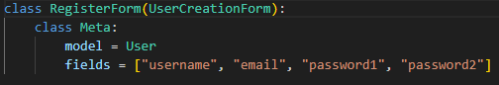

The view for the register form is very similar to the forms you would use to create a post on the portfolio_app

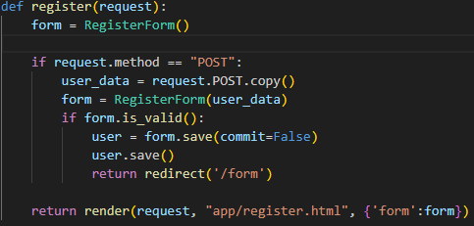

After a User is created we will need to create a group

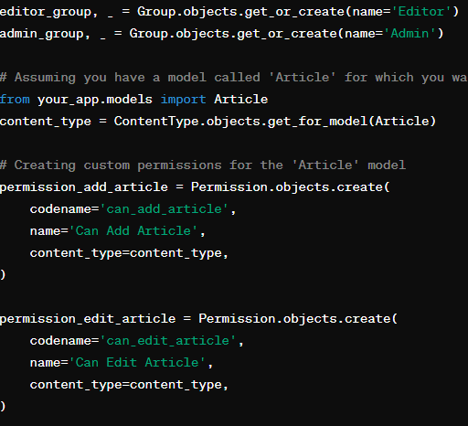

As you can see we can edit the permissions of the groups directly here

We can then assign a user to the group:

